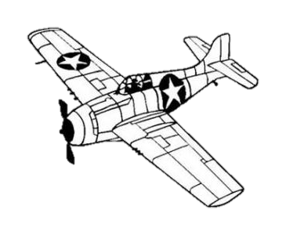
EAA 2024
Warbird Pre-Show Sign In
Credit Card Authorization
Thurs. July 18th – Sun. July 28th
www.baslerflightservice.com
Email: bfs@baslerflightservice.com
Phone: 920-236-7827
Fax: 920-236-7833

This form is not shared with EAA Warbird Registration.
 | Enter Info on This Side
Tail Number
Type of Aircraft (color, description)
Name
Cell Phone Number
Email Address
Address
City, State, and Zip
Credit Card Information | CC#  EXP:  CVV: Billing Zip Code:
Other Aircraft to be charged on this CC?
Multiple Fuelings Expected? | Yes No

Customer Signature __________________________________________
Customer must sign on the above line for Basler to charge any fuelings to this credit card.

For Office Use Only

Date__________ Card__________ M. List__________

